Rooted in Resilience: An Art Project Inspired by the Resilience of Nature in the Urban Environment.

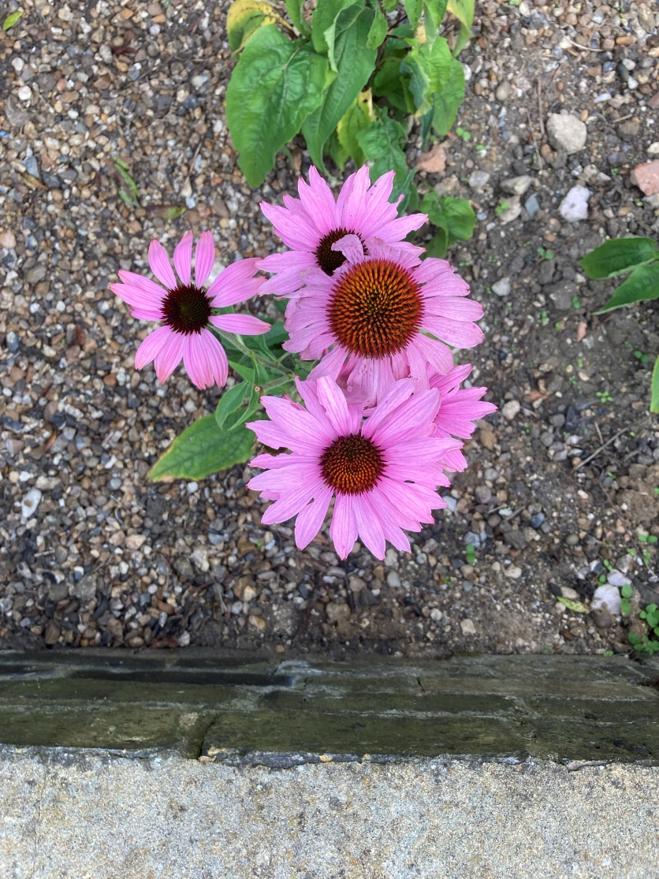

Exhibtion of artworks to be held at St Mark’s Hall/Church on 1 March 2025 [11-4]. Featuring Urban Botanica prints by Access to Art and Design students from South Essex College. And other artists!

The day will also include refreshments and all-age art and craft activities, such as making cyanotypes from found objects from the natural world around the church.

Bids can be made on the artworks, raising funds for St Mark’s and Southend Care Bank